AI ASSISTED CODING
LAB-14
ROLLNO:2403A52082
BATCH-04
TASK-1:
PROMPT: Create a clean, responsive web page layout using HTML and CSS. The page should include:
- A header with navigation links (e.g., Home, About, Contact)
- A main content section with placeholder text and images
- A footer with copyright and contact information
The layout must adapt gracefully to desktop, tablet, and mobile screen sizes using media queries. Use semantic HTML5 elements (, , ) and Flexbox or Grid for layout. Ensure the design is visually organized, with spacing, alignment, and readable fonts. Include comments in the CSS to explain responsive behavior.
CODE:
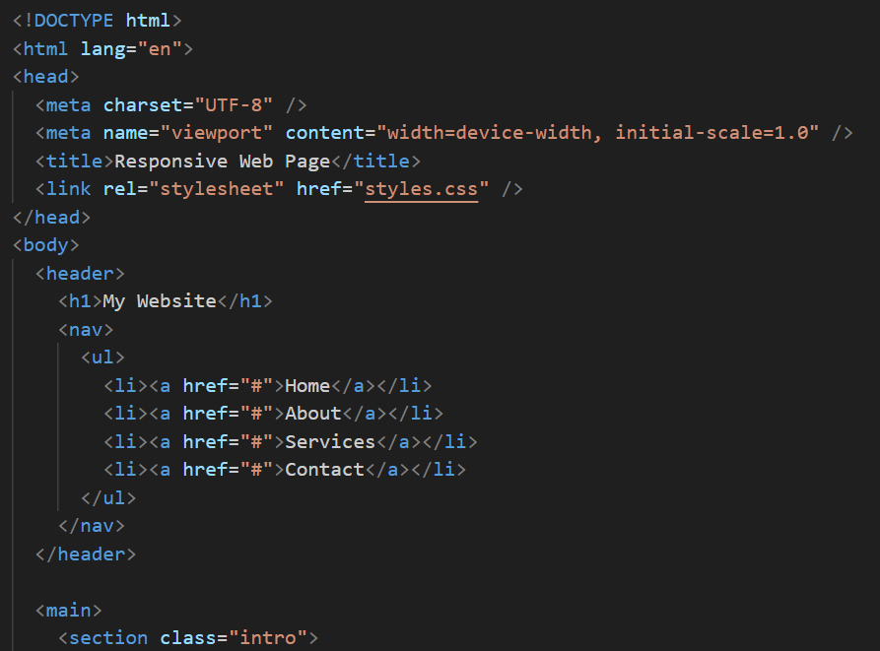
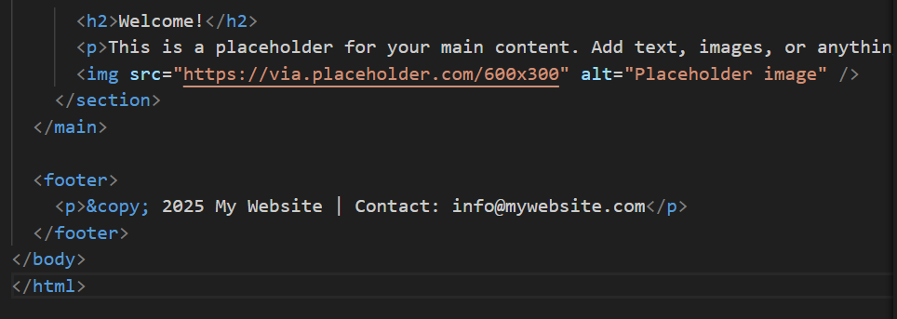
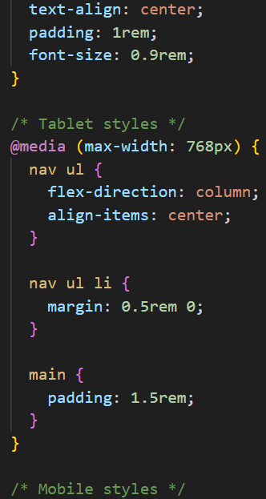
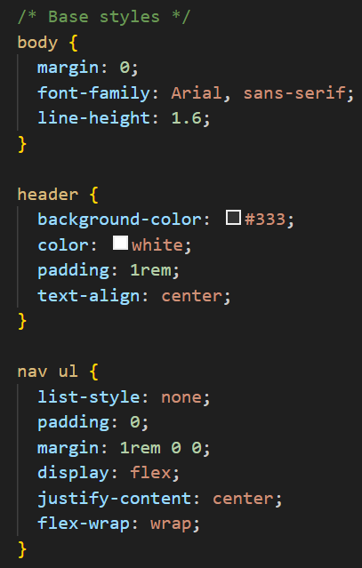
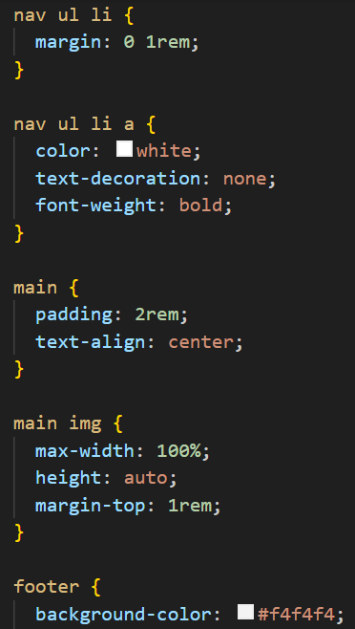
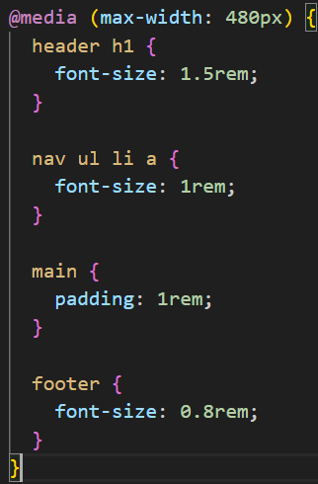
OUTPUT:
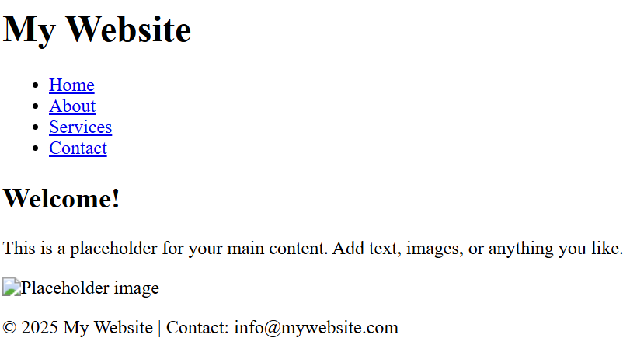
- OBSERVATION: File is semantic: uses <header>, <nav>, <main>, <section>, and <footer>.Meta viewport and lang attributes are set for mobile and accessibility.Navigation is structured with a ul/li list — good for screen readers.Placeholder image includes an alt attribute (accessible fallback).External stylesheet linked (styles.css) — actual responsive behavior depends on that file.Missing responsive/mobile behavior in markup (no mobile menu or ARIA controls) — handled in CSS/JS if needed.Consider adding landmarks/ARIA roles, meaningful link hrefs, and responsive navigation for small screens.
TASK-2:
Prompt: Generate clean and well-commented HTML and JavaScript code for a web page that includes a button. When the button is clicked, it should display a pop-up alert message saying 'Button clicked!'. The code should be beginner-friendly and easy to understand.
Code:
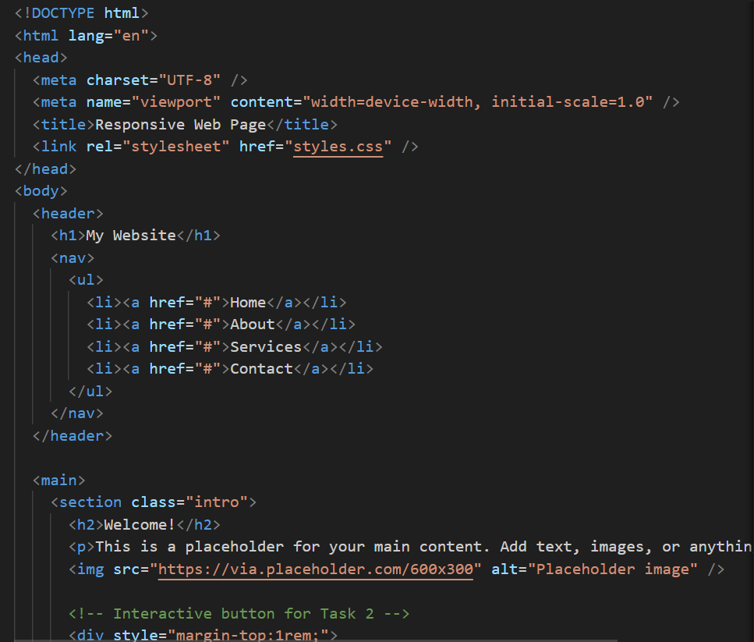
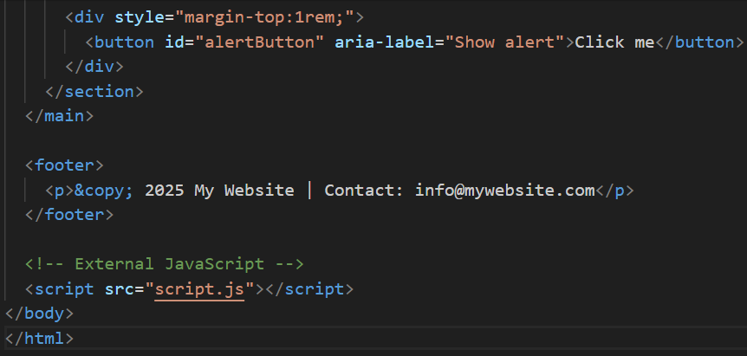
Output:

Observation: A web page was created with a button. When the button is clicked, a pop-up alert message appears as expected. The code is clean and includes comments for clarity.
Task-3:
Prompt: Design a contact form with Name, Email, and Message fields. Use JavaScript to validate that all fields are filled and the email is in a valid format. Show inline error messages for invalid input, and display “Form submitted successfully” when the form is valid.
Code:
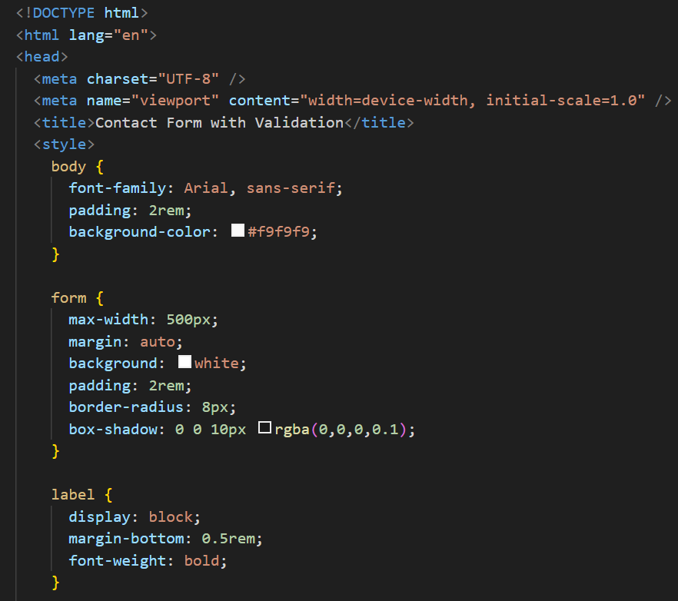
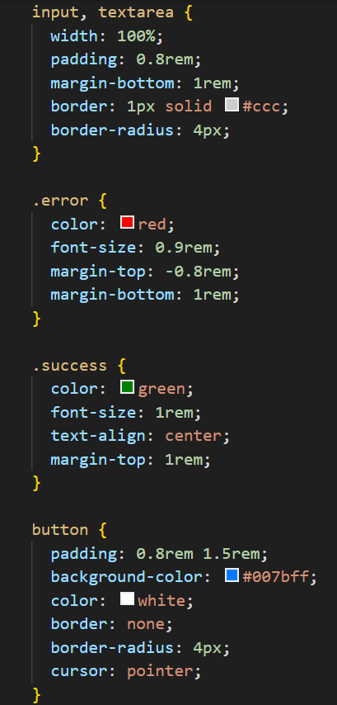
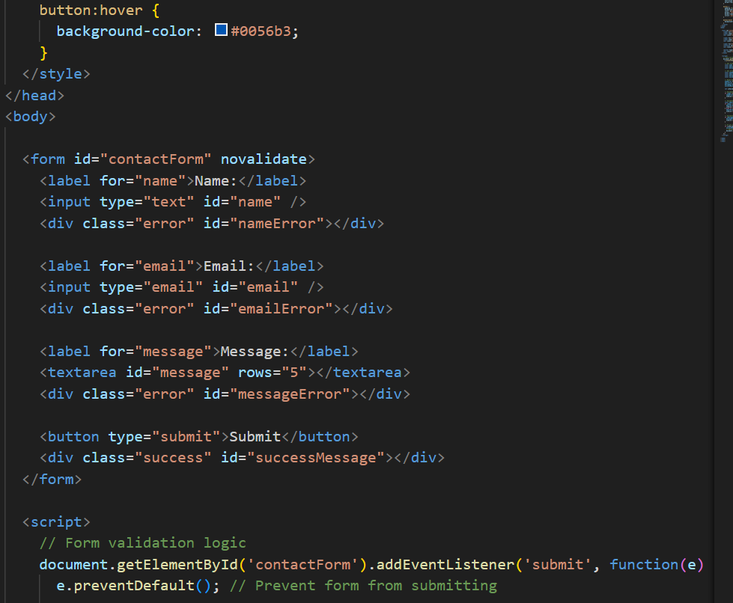
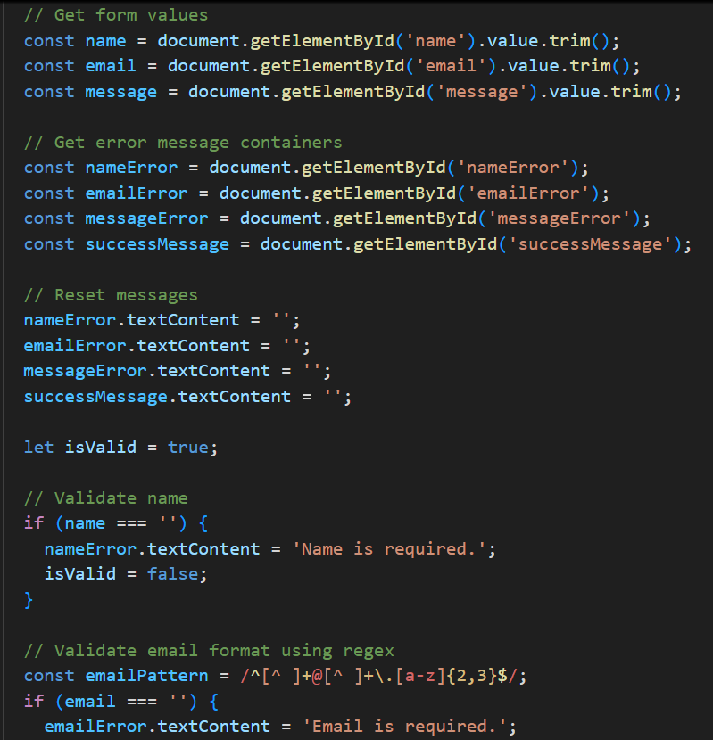
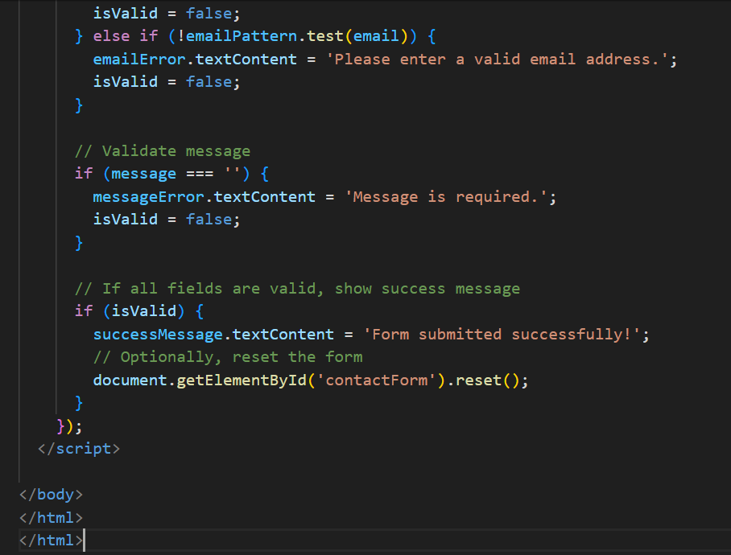

- Output: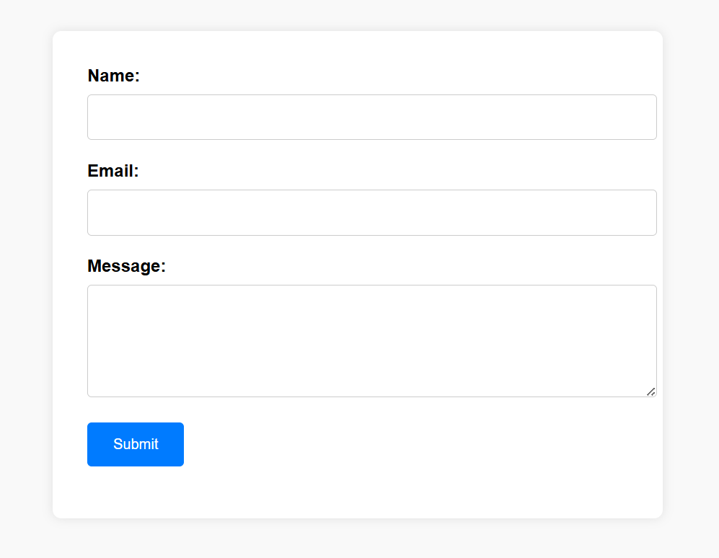
observation: Works: validates name/email/message, shows inline errors, displays success message and resets form.Issue: email regex limits TLD to 2–3 letters (may reject valid addresses).Issue: duplicate closing </html> — remove the extra tag.Suggestion: add name attributes to inputs for real form submission and consider aria-live for success/errors.Good: clean layout, clear error/success UI, simple and easy to maintain.
Task-4:
- Prompt: Improve the provided Dynamic Item List page. Refactor to use unobtrusive event listeners (no inline onclick), add an input to allow custom item names, make add/remove keyboard accessible, and persist the list in localStorage. Ensure accessibility (aria labels, focus management), prevent invalid states (no negative count, handle overflow past "Z"), and separate CSS/JS into external files. Keep behavior identical for basic add/remove and include graceful fallbacks if localStorage is unavailable.

Code:
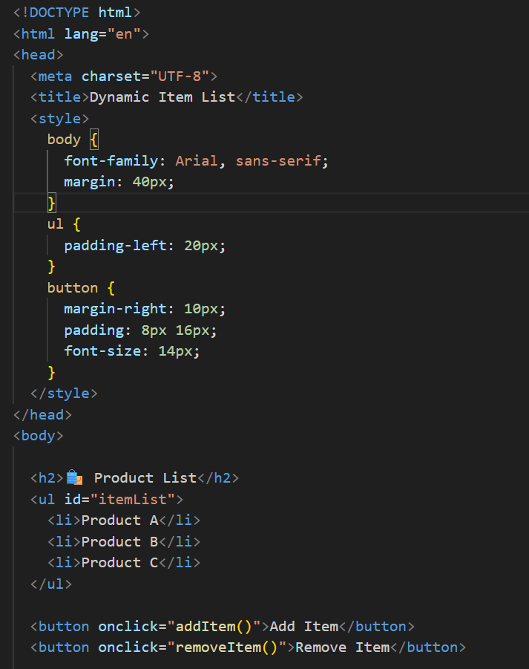
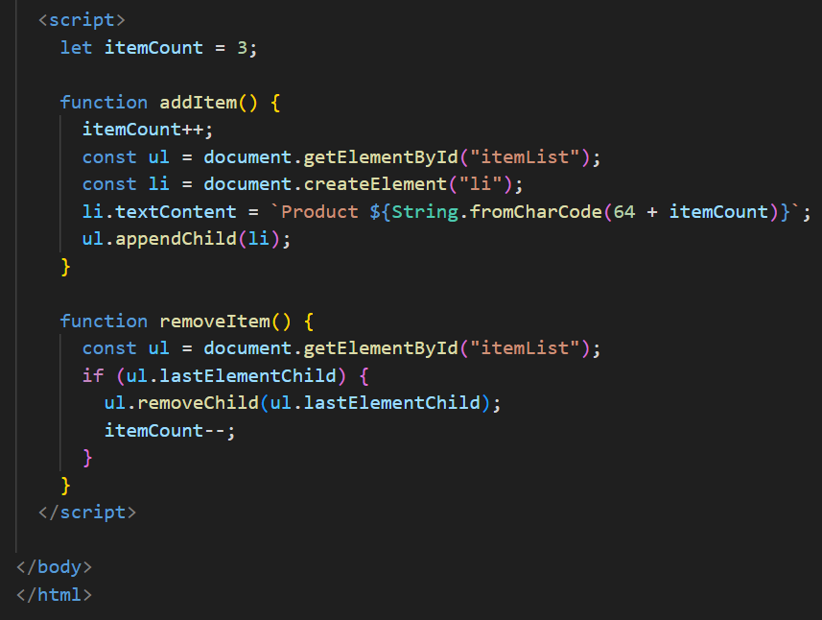
Output:
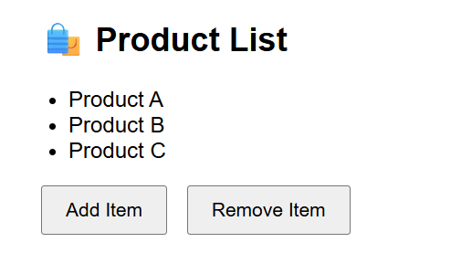
- Observation: Works: adds/removes list items and updates itemCount.Uses inline onclick handlers and global functions — harder to maintain.Item naming via String.fromCharCode will break after "Z" and is not configurable.itemCount can become inconsistent (e.g., decrement below 0) and no bounds checks.No keyboard/ARIA accessibility or focus management.No persistence (list resets on reload) and CSS/JS are not separated.
TASK-5:
PROMPT: Refactor the modal page to use unobtrusive JS (addEventListener), move styles and scripts to separate files, add accessibility (role="dialog", aria-modal, aria-labelledby), trap and restore focus, support closing with Escape, prevent background scroll while open, and respect prefers-reduced-motioN.

CODE:
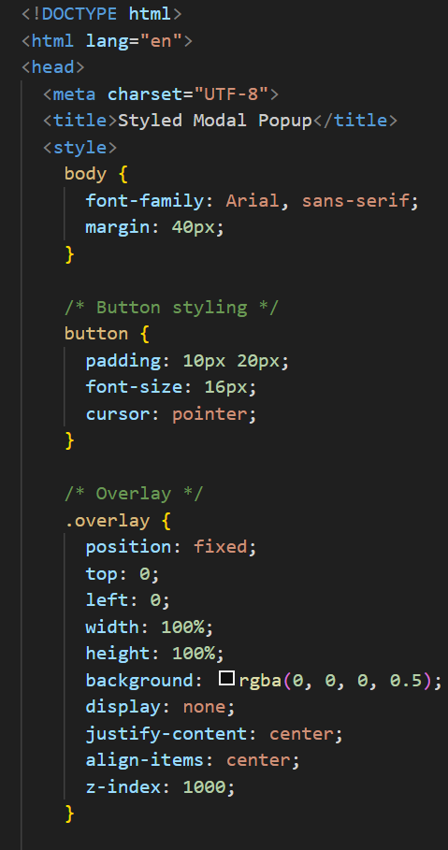
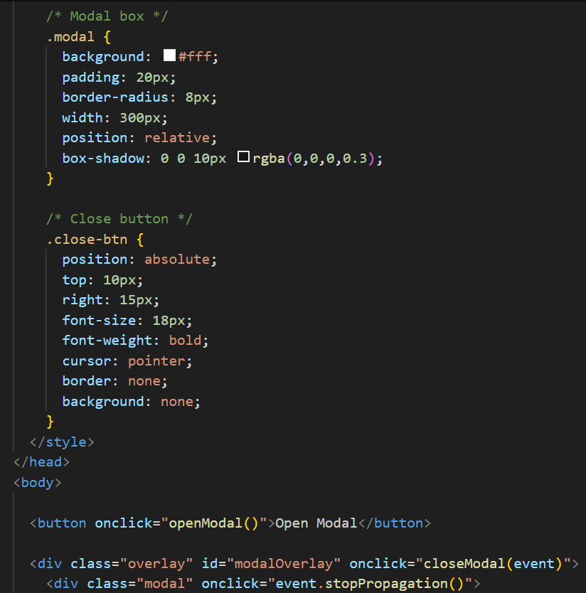
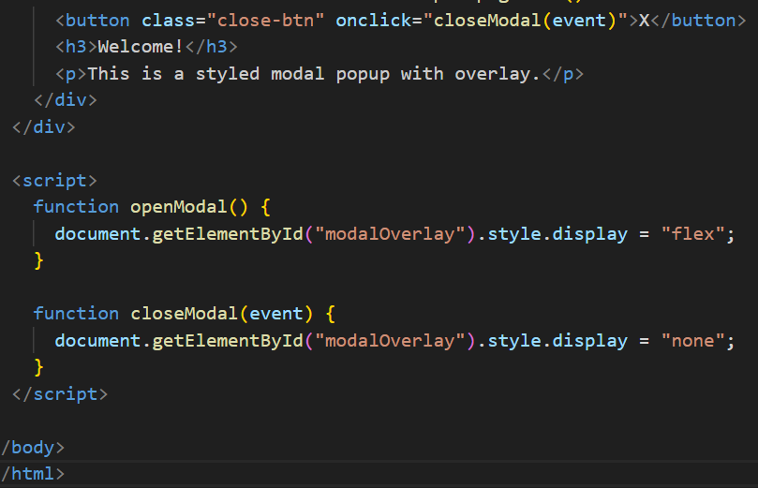
OUTPUT:
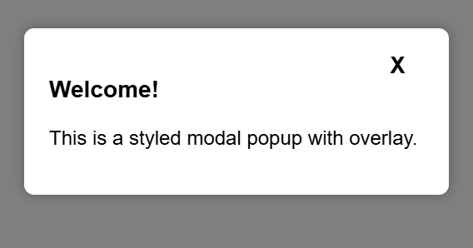
- OBSERVATION: Works: modal opens and closes and overlay blocks background clicks.
- Issues: uses inline onclick handlers, no ARIA/keyboard accessibility (no Esc close or focus trap), no scroll lock, no separation of CSS/JS, and may not announce state to screen readers.

